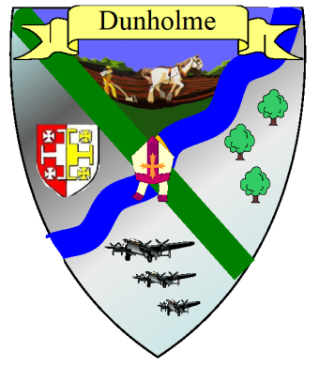

**Dunholme Parish Council**

20 Monckton Way, Dunholme, Lincoln, LN2 3QL

Tel: 01673 895111

Email: [dunholmepc@btinternet.com](mailto:dunholmepc@btinternet.com)

Website: www.parishes.lincolnshire.gov.uk/Dunholme

##### Notice of Conclusion of Audit

**For the year ended**

**31st March 2024**

**Audit Commission Act 1998**

**The Accounts and Audit Regulations 2012**

Date of Notice 27th September 2024

**Notice**

The Audit of the Council's accounts for the above year has been concluded on 18th September 2024 by PKF Littlejohn LLP.

These can be viewed on the Parish Councils website [www.parishes.lincolnshire.gov.uk/Dunholme](http://www.parishes.lincolnshire.gov.uk/Dunholme)

**Rights**

A local Government Elector for the Parish may inspect or take copies of the Statement of Accounts and Auditors Certificate and Report by arrangement with the Clerk.

To arrange a suitable date and time please contact the Clerk on 01673 895111. Where the Clerk is unavailable there is an answer machine in use 24 hours a day.

Please note that charges may be made for copies of this report in accordance with the Councils Publication Scheme.

Signature of person giving Notice on behalf of the Council:

**L. Richardson**

**Mrs Laura Richardson**

**Clerk and RFO to the Council**